|  |  |  |  |
| --- | --- | --- | --- |
| No |  | Hour | Note |
| 1 | Edit custom color | 8 |  |
| 1 | Able to change name (Does not need to have product link) | 8 |  |
| 2 | Able to add rows without name. Manual description with prices*qty which can be added with total | ??? | We try find out solution |
| 3 | Chat Box able to Read from oldest to newest | 4 |  |
| 4 | Design studio standard default screen (g5000) | 2 |  |
| 5 | When user clicks ONCE on the product it will go to the next screen to pick a color automatically | 8 |  |
| 6 | Able to sort schedule by order number, ship date, quantity, etc | 12 |  |
| 7 | Email saved designs to users | 14 |  |
| 8 | Artwork background   * Upload unlimited about of files * Save button saves information | 8 |  |
| 9 | Proof Layout  -- add artwork files | 18 |  |
| 10 | Saving Design name and Email address before user sees prices. They have option to save again to save prices! | 8 |  |
| 11 | About calculation price   * add design name and email * user put information in and it will go straight to show prices * if user clicks save again and it will have pop up that says EMAIL ME my design. No link | 14 |  |
| 12 | able to change sizes/quantity in order | 8 |  |
| 13 | Edit custom color | 8 |  |
| 14 | Edit upload cipart function   * Edit category list * Can upload mutile file for 1 category | 40 |  |
| **Total** | | **160** |  |

Bugs

1) Pantone color (Cannot see full name!)

2) Changing color (Cannot click to change color. User has to Hold down mouse button and drag to change color.

- Should be able to click to change.

-Custom color should have separate line to show user they can pick custom color.

-user knows that separate one is custom colors

-user clicks any color ONCE it will change

3) Wrong text: on product page: Should Say “Starting” not stating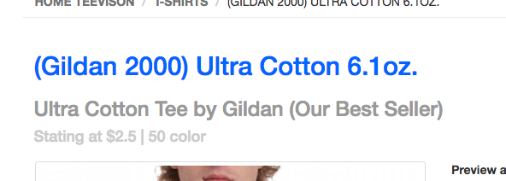

4) Text issue in mobile view. (When adding text in design studio under mobile view, text does not show up!)

5) Remove tip section. Its not working correctly. We will fix later.

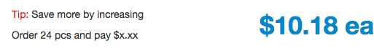

6) Misspelled text: Should say receive it by: (space) Mon, April 3

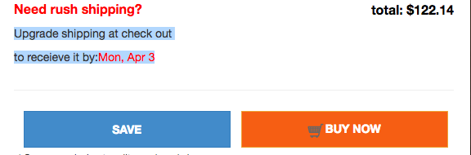

7) Button should say Start designing Here!”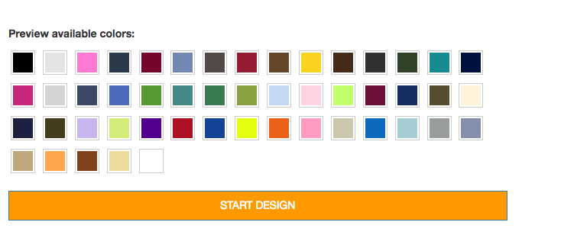

8) Clipart adding/uploading option: is too difficult

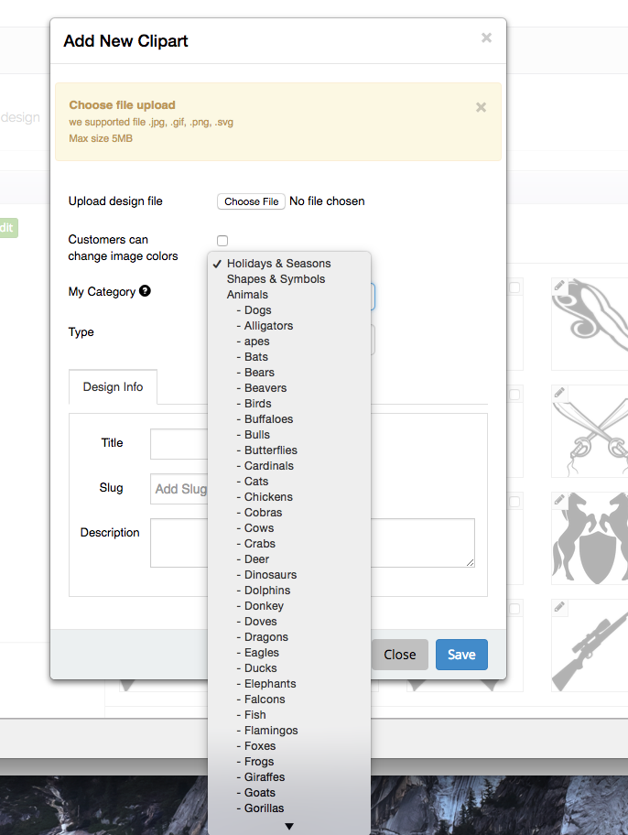

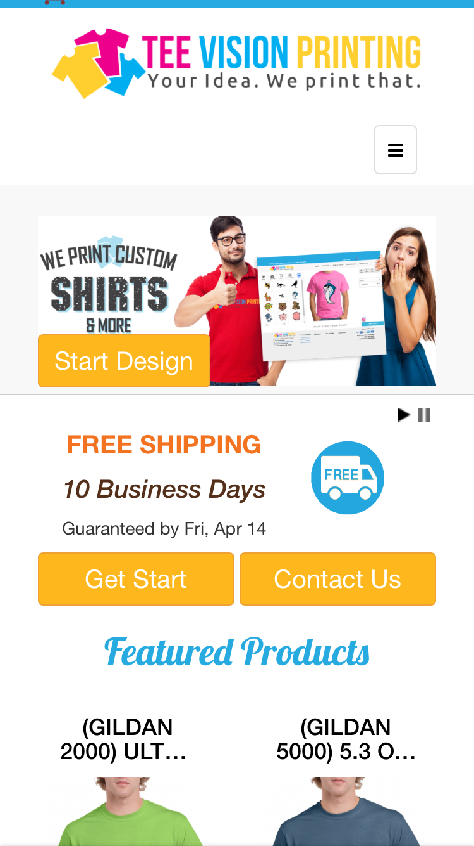 ( mobile view ) should say Design Now! not Get start. (remove start design button)

9) cannot download or see customers name/number list, (cannot see customers comments and instructions.)

11) cannot remove approved proof and add new proof to save.

12) when in apparel order page, artwork page, proof page it is missing the following (this was from job before)



Future things to do:

1. Able to change name (Does not need to have product link)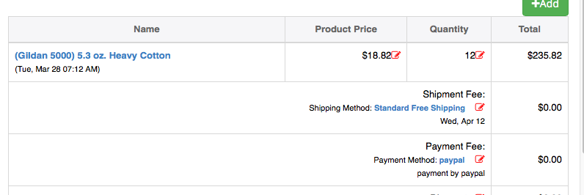
2. Able to add rows without name. Manual description with prices*qty which can be added with total
3. Chat Box able to Read from oldest to newest. Also show news window first.
4. Design studio standard default screen (g5000)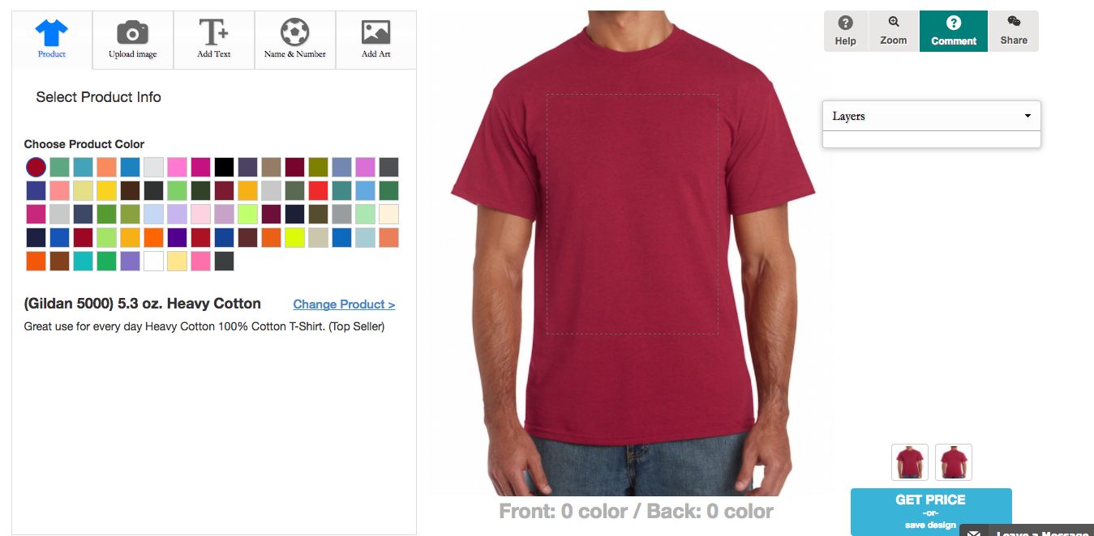
5. when user clicks ONCE on the product name (for example next level 3600)

—it will go to the next screen to pick a color automatically.

user does not have to click “design this” because when clicking once it already goes to next step.

1. Able to sort schedule by order number, ship date, quantity, etc. By clicking on the name of the title it will sort it by date or by alpha. Please log into freshprintsshop.com for example. My User id is [printyourlogo@gmail.com//](mailto:printyourlogo@gmail.com//) password: Smiley22!
2. Email saved designs to users: (when user saves design, it will email them a copy of that to their email address, it will also, send us a notification as well)

IMAGE BELOW NEXT PAGE

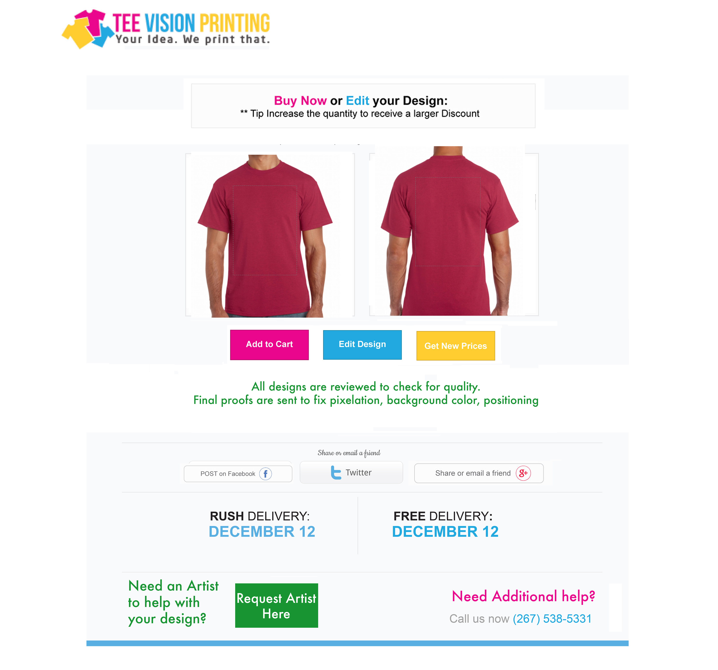

8) artwork background (unfinished from project 6)

--- remove option of only uploading 2 images. I wan to upload unlimited about of files.

--- Save button saves information but if want to add more please option. Make window smaller please follow the layout from project 6.

9) Proof Layout

-- add artwork files (unlimited amount) will create new layout

10) Saving Design name and Email address before user sees prices. They have option to save again to save prices!

**- About calculation price**

- user click get prices.

- pop up appears to say “save your design first to make edits later”

- add design name and email

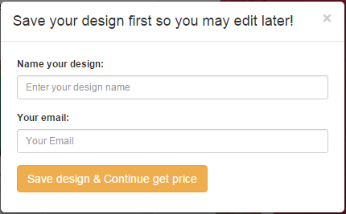

---user put information in and it will go straight to show prices

- won’t show design link

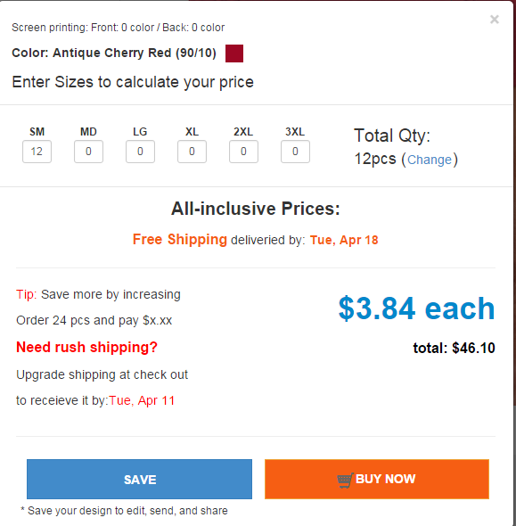

3) if user clicks save again and it will have pop up that says EMAIL ME my design. No link

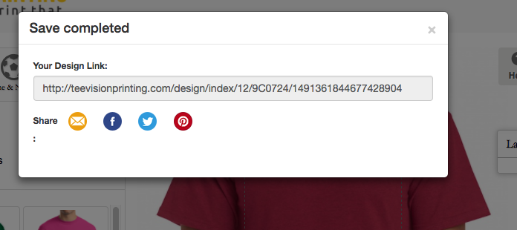

11) able to change sizes/quantity in order 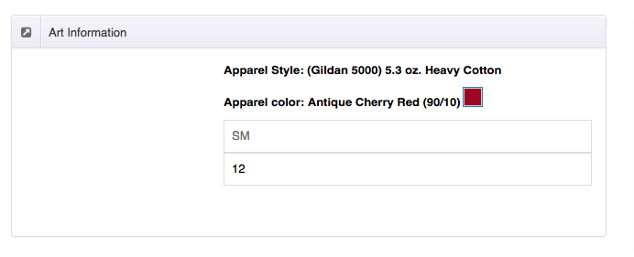

12)

* **About Back End**

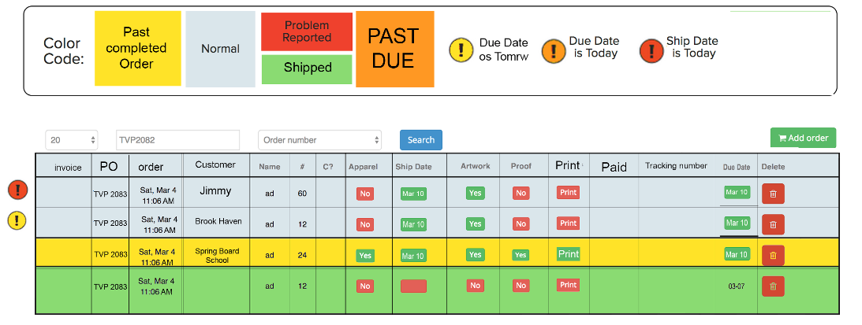

we are missing 2 things here the invoice section where we can manually input text or numbers next to order

and the top color code